Closest-Pair Problem by Brute Force
The closest-pair problem finds the two closest points in a set of n points. It is the simplest of a variety of problems in computational geometry that deals with proximity of points in the plane or higher-dimensional spaces.
Consider the two-dimensional case of the closest-pair problem. The points are specified in a standard fashion by their (x, y) Cartesian coordinates and that the distance between two points p_{i}(x_{i}, y_{i}) and p_{j}(x_{j}, y_{j} ) is the standard Euclidean distance.
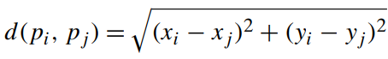

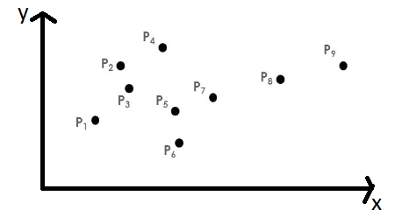

Figure 2.a. Points on a plane
In the above figure closest pair algorithm finds the nearest points in a plane.
The following algorithm computes the distance between each pair of distinct points and finds a pair with the smallest distance.

ALGORITHM BruteForceClosestPair(P)
//Finds distance between two closest points in the plane by brute force
//Input: A list P of n (n ≥ 2) points p₁(x₁, y₁), . . . , p_{n}(x_{n}, y_{n})
//Output: The distance between the closest pair of points
d←∞
for i ←1 to n − 1 do
for j ←i + 1 to n do
d ←min(d, sqrt((x_{i}− x_{j} )² + (y_{i}− y_{j} )²)) //sqrt is square root

return d

Basic Operation: Squaring a number
The number of times it will be executed can be computed as follows:
